Table of Contents

Positive displacement pumps: 2

Applications: 2

Liquids used: 2

Pressure 2

Flow rates: 2

Use of relieve valve: 2

For controlling the flow: 2

Check valves at suction side: 2

Use of filter: 2

Reversing rotation: 2

Types: 2

[Figure 1 Gear Pump](../../mohannad/Downloads/College/7th%20Term/FLUID%20MACHINERY/Lab%20Reports/lab1/Positive%20displacement%20pumps.docx%23_Toc27765184) [3](../../mohannad/Downloads/College/7th%20Term/FLUID%20MACHINERY/Lab%20Reports/lab1/Positive%20displacement%20pumps.docx%23_Toc27765184)

[Figure 2 screw Pump](../../mohannad/Downloads/College/7th%20Term/FLUID%20MACHINERY/Lab%20Reports/lab1/Positive%20displacement%20pumps.docx%23_Toc27765185) [3](../../mohannad/Downloads/College/7th%20Term/FLUID%20MACHINERY/Lab%20Reports/lab1/Positive%20displacement%20pumps.docx%23_Toc27765185)

[Figure 1 piston Pump](../../mohannad/Downloads/College/7th%20Term/FLUID%20MACHINERY/Lab%20Reports/lab1/Positive%20displacement%20pumps.docx%23_Toc27765186) [3](../../mohannad/Downloads/College/7th%20Term/FLUID%20MACHINERY/Lab%20Reports/lab1/Positive%20displacement%20pumps.docx%23_Toc27765186)

Rotodynamic pumps (dynamic head pumps): 4

Applications: 4

Fluids used: 4

Pressure: 4

Flow rate: 4

Use of relieve valve: 4

For controlling the flow: 4

Check valves at suction side: 4

Use of filter: 4

Reversing rotation effect: 4

Examples 4

Positive displacement pumps:

Positive-displacement pumps operate by forcing a fixed volume of fluid from the inlet pressure section of the pump into the discharge zone of the pump. The inlet and outlet are in the same dir.

Applications:

Used in systems where the flow required is steady and the possibility of stopping the flow is low.

Liquids used:

PDPs require the usage of high density and high viscosity fluids to tolerate the clearance in the pumps body itself.

Pressure**:**

* Positive-displacement pumps frequently are used in hydraulic systems at pressures ranging up to 5000 psi within mechanical limitations and theoretically, infinite pressure to move fluids.
* Regardless of the pressure at the inlet, the fluid is moved at the same speed.

Flow rates:

Since hydraulic power equals the flow rate multiplied by the pressure, the flow rates of PDPs isn’t that big compared to DHPs

Use of relieve valve:

Because of the high pressure, the delivery pipe must not be closed or serious damage will occur to the pump, that’s why a pressure relieve valve must be placed in parallel to the pump itself so whenever the deliver is clogged and pressure rises in the pump, the valve opens

For controlling the flow:

Controlling the speed of the motor is the only way to control the flow. (Other than replacing the pump with bigger/smaller pumps)

Check valves at suction side:

* Since rotary DHPs have the ability to reverse the flow simply by reversing the direction of spinning and since the absence of back flow, the use of check valves is not necessary.
* Reciprocating pumps WILL backflow if check valves are absent.

Use of filter:

PDPs are durable and will pump fluids with residuals in it. Since there is a limit to the size of the clearance, only big residuals should be filtered out.

Reversing rotation:

* Rotary PDPs can reverse flow by reversing the direction of spinning.
* Reciprocating PDPs can reverse flow simply by flipping the check valves (or flipping the pump itself). However, reversing the direction of rotation in piston pumps will not differ.

Types:

* rotary (ex: gear pump, screw pump)
* reciprocating (ex: piston pump)

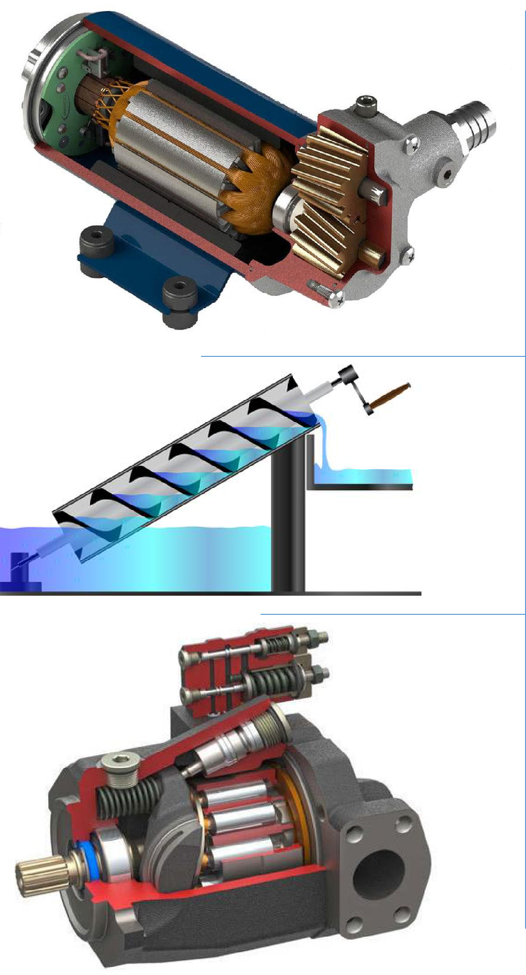

Figure 1 Gear Pump

Figure 2 screw Pump

Figure 1 piston Pump

Rotodynamic pumps (dynamic head pumps):

A Rotodynamic pump is a device where mechanical energy is transferred from the rotor to the fluid by the principle of fluid motion through it.

These pumps are classified according to the main direction of fluid path through them like (i) radial flow or centrifugal, (ii) axial flow and (iii) mixed flow types

Applications:

The flow can be controlled so it is best used for variable demand systems.

Fluids used:

Lower in viscosity than PDPs to allow the shape of the impeller to take effect

Pressure:

The pressures are relatively lower. They are referred as constant pressure pump as the discharge pressure through these pumps cannot be varied without changing the physical conditions of the pump while PDP are referred as constant discharge pumps because the volume/gap between the piston & cylinder in these pumps are constant.

Flow rate:

The flow rate is higher. . Also flow rate is affected by the pressure at the inlet.

Use of relieve valve:

There is no need because when the delivery side is closed, the fluid will just rotate inside the impeller (it will heat up eventually but no immediate danger)

For controlling the flow:

The same principle exists: controlling the speed of the impeller

Check valves at suction side:

There is no need for backflow doesn’t exist. However, one can be used for priming

Use of filter:

There are multiple choices for the shape of impellers themselves each can tolerate a certain amount of impurities. However, the more resilient the impeller, the less efficient the pump.

Reversing rotation effect:

Because the rotodynamic pumps depend on how the fluid reacts upon moving on the impeller itself, reversing the direction of the flow/rotation will make the pump work at worst efficiency and discharge.

Examples**:**

Radial flow pipes, axial flow pipes and mixed flow pipes

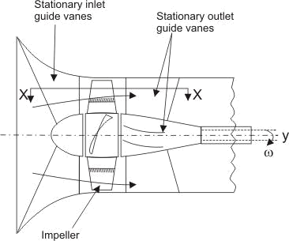

Fig4. Axial flow pump

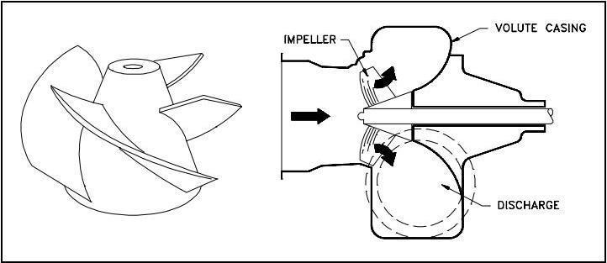

Fig5. Mixed flow pump

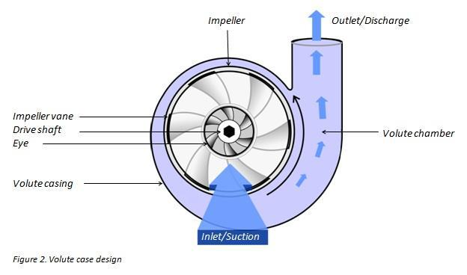

Fig6. Radial flow pump (centrifugal pump)

*Table 1 Comparison summary*

|  |  |  |
| --- | --- | --- |
| **Point** | **PDP** | **Rotodynamic** |
|  |  |  |
| **Applications** | Constant demand system | Variable demand system |
|  |  |  |
| **Liquids used** | High viscosity high density | Low viscosity low density |
|  |  |  |
| **pressure** | Higher pressures | Lower pressures |
|  |  |  |
| **Flow rate** | Lower flow rates | Higher flow rates |
|  |  |  |
| **Use of relieve valves** | mandatory | unnecessary |
|  |  |  |
| **Controlling the flow** | Controlling the speed of motor | Controlling the speed of |
|  |  | motor |
|  |  |  |
| **Check valves at suction** | Mandatory in reciprocating | unnecessary |
| **side** |  |  |
|  |  |  |
| **Use of filter** | Only to filter out large impurities | Only to filter out large |
|  |  | impurities |
|  |  |  |
| **Effect of reversing** | Flow reverses | Flow stops |
| **rotation** |  |  |
|  |  |  |
| **Examples** | Rotary: gear pump, screw pump | Axial |
|  | Reciprocating: piston pump | Mixed |
|  |  | radial |
|  |  |  |